U A E
Week One: This has been our first week here in UAE. It has been a learning experience mainly from trying to adjust to the change in culture. The biggest challenges that I have had this week has been recovering from the time-zone change. I am still very jetlag and my sleeping schedule has not adjusted. I am sleeping all during the day and up all night. Another challenge has been adjusting to the cultural rules. With this being a Muslim country, the rules here are very strict when it comes to gender. Honestly, it appears the males are far more reckless and have far more freedom than females here. There have been numerous incidents that we have had trying to leave out hostel to go anywhere, whether that be the mall, a restaurant, or site-seeing. There was one particular incident when we were with our chaperone Amber attempting to go to the water park. This was around 8am. As a part of custom, we have to ask permission from the Madam, she typically will give us a curfew, and we must sign out in the book. After complete all necessary protocols, the security guard (a male adult) refused to let us leave because he “had not seen us before”. We had provided our UAEU IDs to him and explained that we were here for research, yet he refused. We went through protocol the night before trying to go to the mall and he walked up to the car asking us a series of questions before letting us pass so I had no idea how he was now saying that he had never seen us before. Not to mention that we are the only African-American people in our Maqam and we are always together. The situation was resolved when one of the female administrators had to come and argue with the security guard that we have already asked Madam, she approved, and we signed out. Situations like this never really eased up but I just had no choice but to adjust to the new rules. In the end, we were in a completely new environment and country.
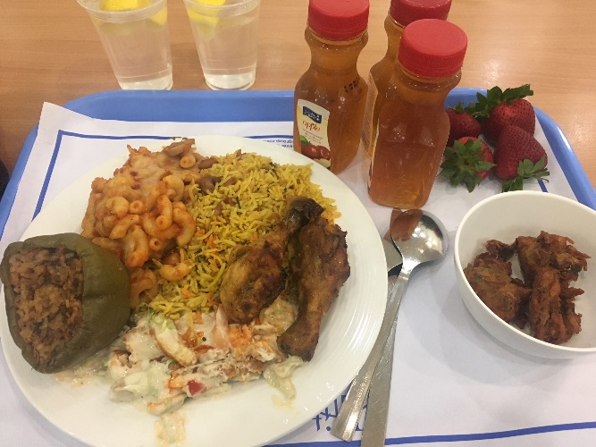
This week, we also got a tour of campus, and the engineering & IT departments, and met our research professor Dr. Bobby Mathew and Dr. Mohammed, who I assume oversaw the coordination of our stay. He was our go-to resource if we needed anything or had any issues. Both are fantastic individuals. Dr. Bobby seems incredibly nice and patient which is definitely a worry that I had before coming. I was worried that our research professor would be strict and that this would make our research harder. I am very excited to start. We went to the Al Ain mall this week. The mall has an ice rink inside and many designer clothing stores and American restaurants. The crazy part about it is that this mall I considered the “lesser” mall! The food here is quite tasty! It consists of mostly variations on chicken and rice. However, everything is very starchy and heavy & there aren’t many healthy options. With this being Ramadan, this is already going to be extremely hard for me. I am definitely not used to have to wait until 6:30pm to eat every day. You are also not allowed to drink water or snack in public because it is considered rude.

Week Two: In the beginning of this week we visited Al Jahili Fort. It is a landmark in Al Ain, Abu Dhabi that is a museum about a man who travelled through the Dubai desert many years ago. My team & I enjoyed ourselves and took many pictures. We then walked to find the Al Ain Oasis. It was very hot and the heat was draining while we were walking. At the Oasis, I heard the call for pray clear as day for the first time and it was truly beautiful. Later that night we met up with a friend that Cameron met in his hostel who showed us around Al Ain and took us to local restaurants. We even found a Krispy Kreme!
On Friday, we went mini-golfing on a mountain and it was one of the best experiences I’ve had on the trip yet! The mini-golf course was at a hotel that happened to be on the mountain in Al Ain. Aside from having the golf course, there was also a pool with waterpark, 2 poolside restaurants, a pool bar and a small ride that takes you to the edge of the mountain. My team and I (those that went) had a great time! We were able to connect as a team and have a good time together.
Saturday was also a great day for my team and I to explore the area more. We took a trip to the Dubai Mall. The Dubai Mall is everything that I thought it would be and more. The mall is huge! It has over 1000 stores and services, a full indoor aquarium, underwater zoo, an indoor ski resort, an ice skating rink, and so much more. We got to see the Dubai lights and the boardwalk on the water reminded me of that in Chicago. Although they did have a few Arabic restaurants, things are majority American cuisine. Every car that was parked in the garage was a luxury car and they had so many luxurious stores.
If I haven’t yet mentioned, there is an abundance of stray cats all around this country. Everywhere that we went, there were stray cats. I’ve had numerous cats walk inside of my dorm room if my door was open or hear “meow” right outside of my door.
This week as far as our research goes, Dr. Mathews has gone over detail and understanding of our research project. We’ve gone over …. Although this is my first research experience & I have yet to partake in research back at Howard, the educational environment here is very comfortable. The biggest cultural difference if the segregation of campus. While this does not hinder my education in anyway, it is a big difference. Aside from the fact that campus is segregated, the actual labs and classwork tailors to the students and makes sure that the students are understanding the material and goes at their pace. From what I’ve observed with Howard’s engineering department is not the best when it comes to the success of students in their class. I received the exact opposite of this studying at UAEU. Dr. Mathews is very understanding.

Week Three: This week we got further along in our research. We have begun configuring the code for the device and running tests on different factors of the device. The research has definitely picked up and gotten tougher because of the coding. This is my first introduction to coding and although it seems a bit challenging, Dr. Mathews is very understanding and I have been asking as many questions as I have. Dr. Mathews also introduced us to a few of the senior Mechanical Engineers at UAEU. The girls are extremely nice and happen to be working on our same project for their senior design project. I hope that we have an opportunity to hang out with them before we leave.
This weekend, we took another trip back to Dubai. This time, we wanted to spend the weekend out there so that we were able to do more rather than having to drive back to AL Ain each night. We stayed at an AirBnb in Dubai that was actually great price considering all of us. The host was extremely nice and there was an in-home housekeeper who cooked breakfast for us. Overall, the weekend was great. Dubai is everything that you could drem of. The entire country is beautiful. This weekend also coincided with the end of Ramadan and beginning of Eid al-fitr. The call to prayer on this day is heard around the country and it was beautiful to hear. I got it on video. During this weekend, we did a Desert Safari that was immaculate! For the price of $19, the safari included camel riding, henna painting, a live show, dune bashing, and RV riding. I truly had the time of my life at the safari. It was beautiful being in the desert with the Dubai sun on the body! There was also an event at Atlantis Waterpark this weekend called Aquaventure AfterDark. The park was open at night and had music. It seemed to be an event for younger people but it was definitely an experience. I was able to grab a few souvenirs to take back for my family.
My body has definitely had enough of the food at the point. I feel a bit heavy for all the starch I’ve been consuming lately to make up for my starving appetite. The food is tasty though!
3 words to describe how I felt most this week: adventurous, sated, and happy

Week Four: This week is unfortunately our last week! We’ve come very far along with our research. We’ve concluded our code for the microfluidic device. At this point, we’ve been testing the devices based on different factors of the circulating endothelial cells. We are almost done with typing up our first research article! This is very exciting for me considering this will be my first published research article.
This week, we visited the Sheikh Zayed Grand Mosque in Abu Dhabi with a friend that Cameron met from his hostel. He was very nice for offering to drive us all the way to Abu Dhabi and show us around. Sheikh Zayed Grand Mosque is the largest in the country and is the key place of worship for natives. They provide hijabs for the women to wear. We must enter through different entrances than the males and the males don’t have to cover up in any way. While there is an outer portion of the mosque for visitors to congregate, it is a very sacred place and the rules get quite stricter as you walk further into the mosque. They require no shoes to be worn and there are certain poses you are not allowed to do in your pictures. After the mosque, we visited Emirates Palace, an exclusive and luxurious hotel in Abu Dhabi. Inside of this hotel, there are jewelry stores, restaurants, banks, and much more.
On our last day of class Salini cooked all of us a homecooked meal that was fantastic! I had asked her the day before if she knew any place that sold Gulab jamun, which is a sweet dessert almost like a donut that is soaked in sugar syrup. She made some from scratch for all of us! I greatly appreciate Salini and am going to miss her, Dr. Mathews, and everyone else that we have been introduced to and who have helped us throughout our stay.
The last thing we did to conclude our trip was visit a family friend who is a teacher in Al Ain. Ms. Sharonda went to college with my parents at Fisk University and currently resides in Al Ain teaching English to 6th grade girls. I am truly grateful my team and I were able to connect with her because I was able to get a lot of questions I had out about being a black woman living/working in UAE. She showed us the town, took us to some stores so we could finish our souvenir shopping, and she took us out eat. We then went to her place and played some games!
I have truly enjoyed our stay in UAE. UAE was on my bucket list so I am so grateful and blessed for the opportunity. My team has been a delight. Thank you GEAR UP for the nomination!

